Exception Handling

Q1. How can you handle exceptions in Java?
Ans:-The try-catch is the simplest method of handling exceptions. Put the code you want to run in the try block, and any Java exceptions that the code throws are caught by one or more catch blocks.
=>This method will catch any type of Java exceptions that get thrown. This is the simplest mechanism for handling exceptions.
Q2. What is the difference between exception and error in Java?
Ans:-

Sr. No. | Key | Error | Exception
1 | Type | Classified as an unchecked type | Classified as checked and unchecked
2 | Package | It belongs to java.lang.error | It belongs to java.lang.Exception
3 | Recoverable/ Irrecoverable | It is irrecoverable | It is recoverable
4 |  | It can't be occur at compile time | It can occur at run time compile time both
5 | Example | OutOfMemoryError ,IOError | NullPointerException , SqlException

Q3. Why do we need exception handling in Java?
=>Java exception handling is important because it helps maintain the normal, desired flow of the program even when unexpected events occur.
=>If Java exceptions are not handled, programs may crash or requests may fail.
=>The Exception Handling in Java is one of the powerful mechanism to handle the runtime errors so that the normal flow of the application can be maintained.

4. Name the different types of exceptions in Java
Ans:- There are mainly two types of exceptions in Java as follows: Checked exception. Unchecked exception
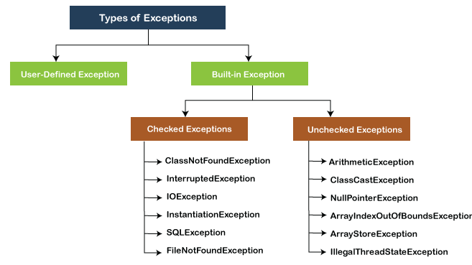
exception is an event that occurs during the execution of a program and disrupts the normal flow of the program's instructions. Bugs or errors that we don't want and restrict our program's normal execution of code are referred to as exceptions. In this section, we will focus on the types of exceptions in Java and the differences between the two.

Q5. Can we just use try instead of finally and catch blocks?
Ans:- Yes, It is possible to have a try block without a catch block by using a final block.

The finally block always executes when the try block exits. This ensures that the finally block is executed even if an unexpected exception occurs.
Can we throw an exception explicitly or manually?
- Describe the use of the throw keyword.
- Ans:-The Java throw keyword is used to throw an exception explicitly.
- We specify the exception object which is to be thrown. The Exception has some message with it that provides the error description. These exceptions may be related to user inputs, server, etc.
- Note: If we throw unchecked exception from a method, it is must to handle the exception or declare in throws clause.

Note: Every subclass of Error and RuntimeException is an unchecked exception in Java. A checked exception is everything else under the Throwable class.

- should we clean up activities such as I/O resources in the finally block?
Ans:
- Describe OutofMemoryError in exception handling.
Ans:
- What is the error of ClassCastException?
Ans:
- Is there any difference between throw and throws in exception handling in Java?
ans
- When should we use the printStackTrace() method?
Ans:
- Provide me with some examples of unchecked exceptions.
Ans:
- Is it illegal to keep an empty catch?
Ans:
- What are the advantages of using exception handling in Java?
Ans:
- Can checked exceptions occur at compiled time?
Ans:
- What happens if a runtime exception occurs?
Ans:
- Describe unreachable catch block error in Java.
Ans:
- In which situation will you not be able to execute the finally block?
Ans:
- Is it possible to throw a statement inside a static block?
Ans:

